# Analyzing the Outcome Variables as a Multivariate Response

## PCA Plots

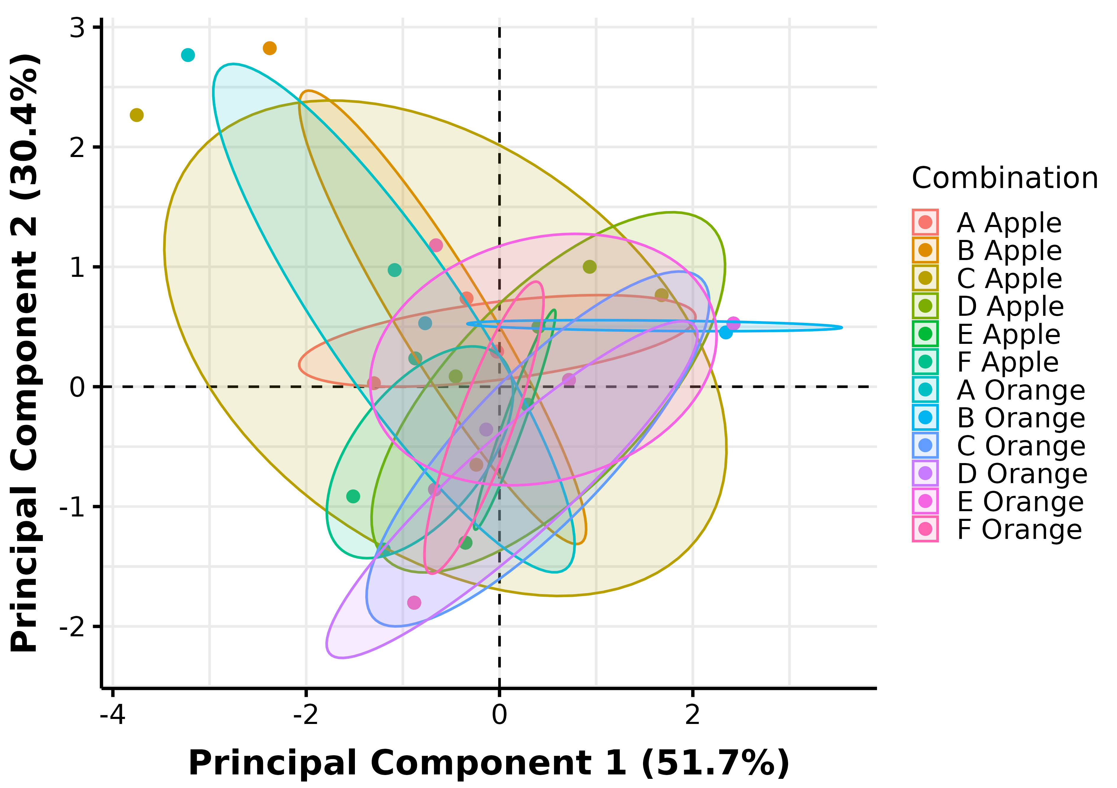

PCA Ellipse-Confidence

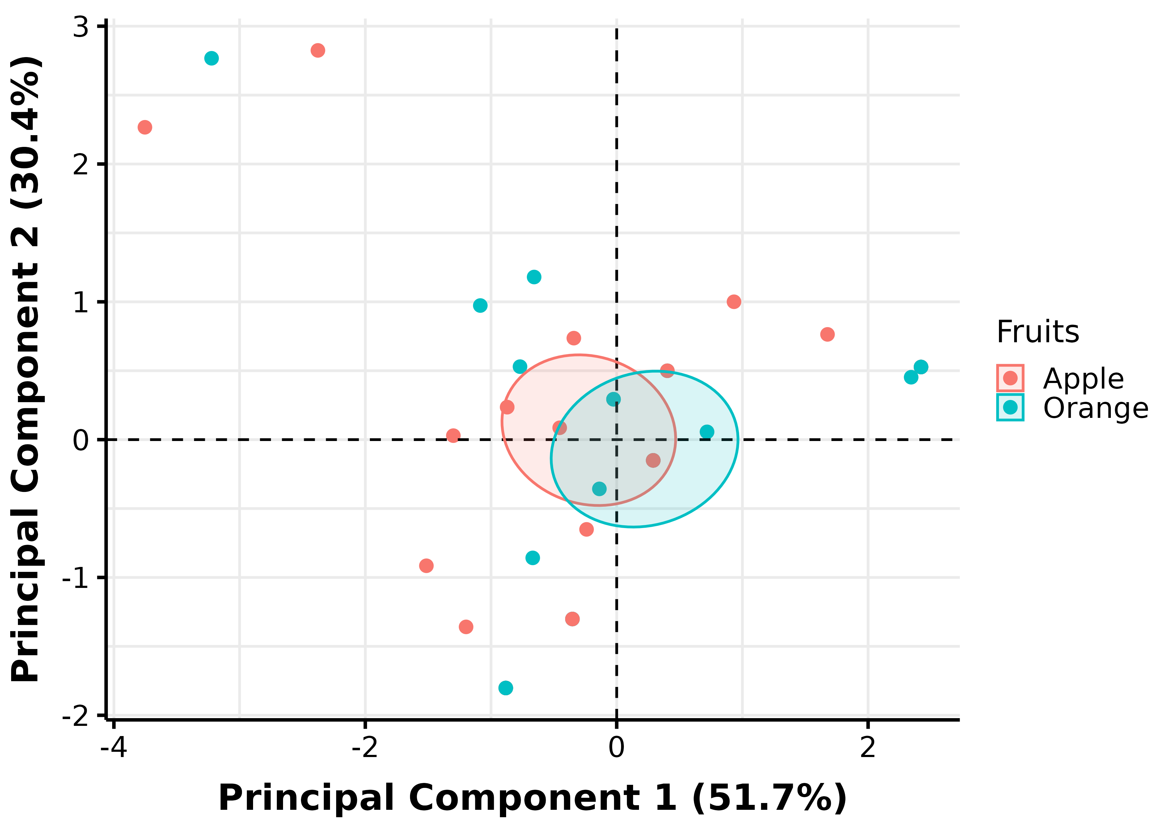

PCA Pooled-Treatment Ellipse-Confidence

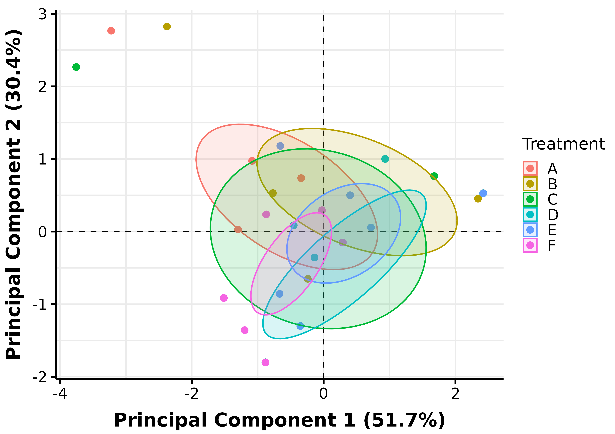

PCA Pooled-Fruits Ellipse-Confidence

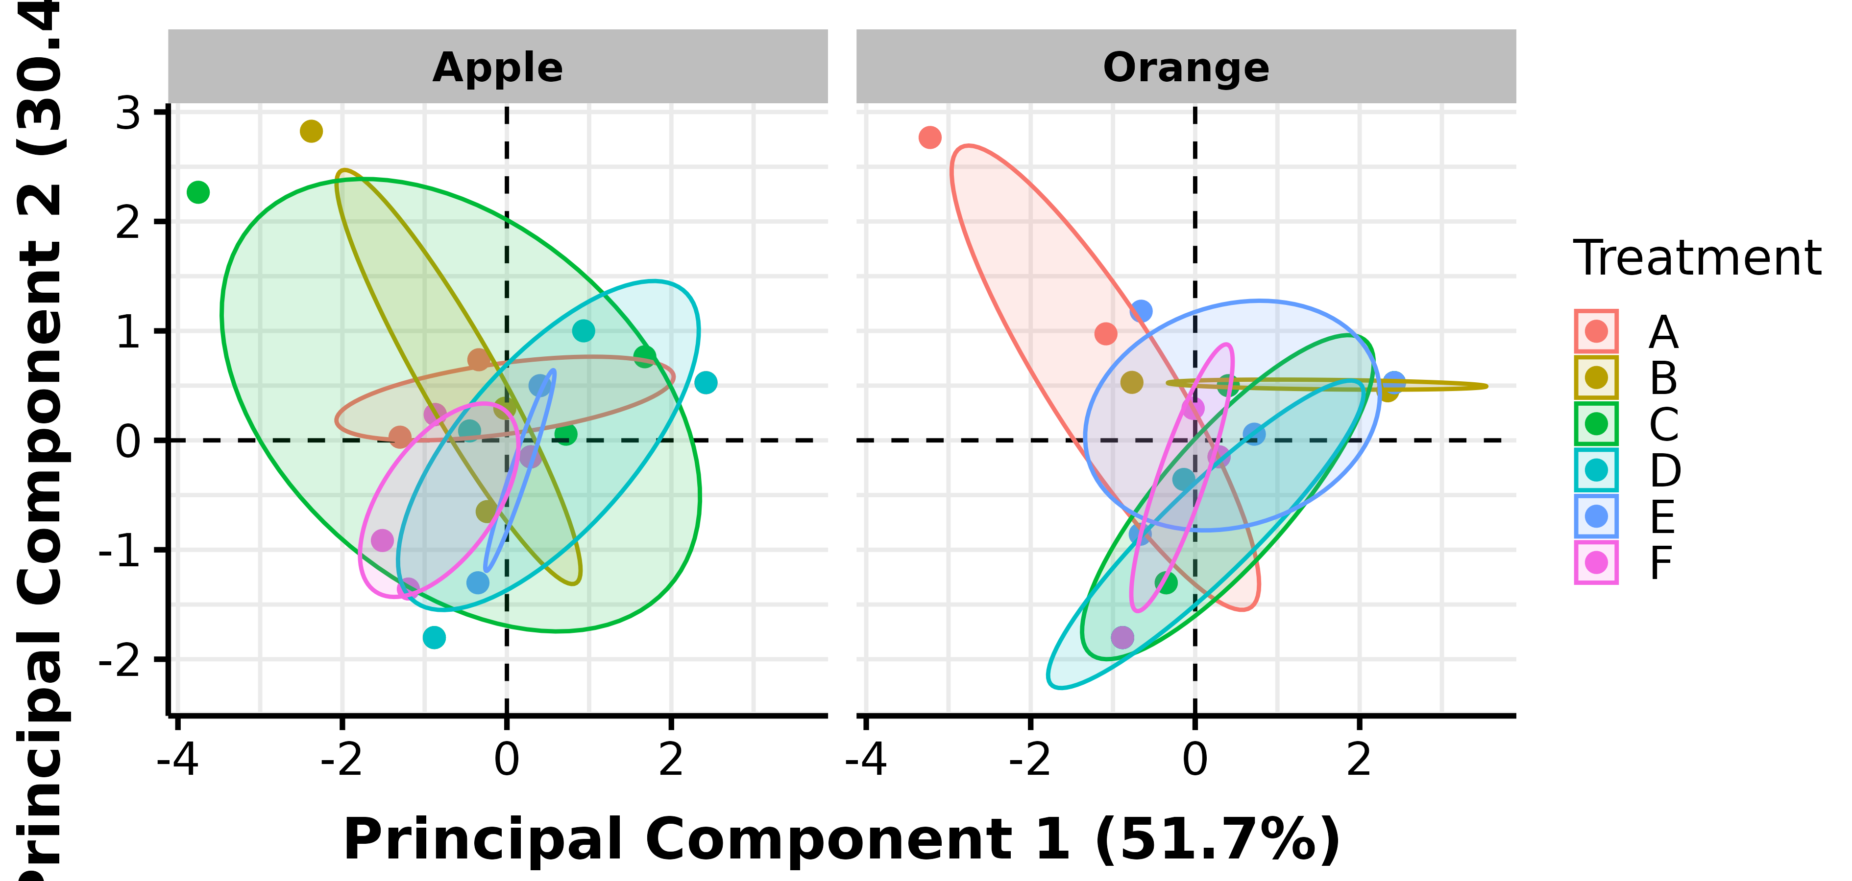

PCA Facet-Fruits Ellipse-Confidence

The 51.7% and 30.4% values in the axes of the figures above describe the percent variation in the data explained by the first and second principal components, respectively.

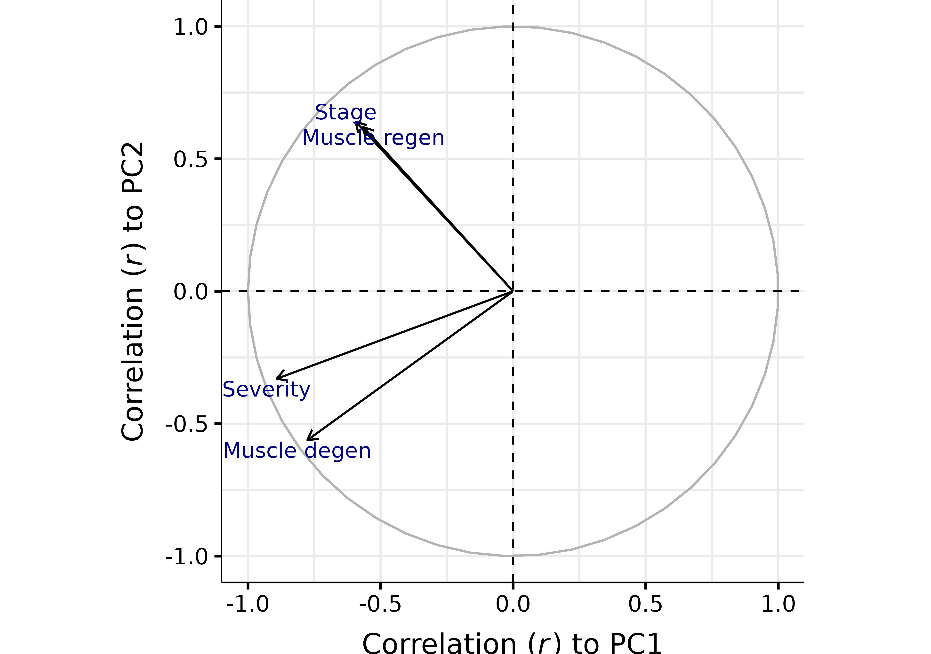

Correlation of Variables to PCs

## Statistical Tables

Table 1. Pearson correlation coefficient (r) between variables and principal components

|  | Severity | Stage | Muscle degen | Muscle regen | PC1 | PC2 |
| --- | --- | --- | --- | --- | --- | --- |
| Severity | 1.0000 | 0.3647 | 0.7876 | 0.2216 | -0.8915 | -0.3303 |
| Stage | 0.3647 | 1.0000 | 0.0559 | 0.4699 | -0.5937 | 0.6397 |
| Muscle degen | 0.7876 | 0.0559 | 1.0000 | 0.1649 | -0.7755 | -0.5618 |
| Muscle regen | 0.2216 | 0.4699 | 0.1649 | 1.0000 | -0.5656 | 0.6194 |
| PC1 | -0.8915 | -0.5937 | -0.7755 | -0.5656 | 1.0000 | -0.0000 |
| PC2 | -0.3303 | 0.6397 | -0.5618 | 0.6194 | -0.0000 | 1.0000 |

Table 2. Contribution of variables to principal components

| **Variable** | **Contrib.PC1** | **Eigenvec.PC1** | **Contrib.PC2** | **Eigenvec.PC2** |
| --- | --- | --- | --- | --- |
| Severity | 38.42322 | -0.6198646 | 8.961203 | -0.2993527 |
| Muscle degen | 29.07204 | -0.5391849 | 25.919057 | -0.5091076 |
| Stage | 17.03734 | -0.4127631 | 33.609218 | 0.5797346 |
| Muscle regen | 15.46741 | -0.3932863 | 31.510523 | 0.5613423 |

The contribution describes how much (in %) of the PC is composed of that variable; a more precise definition is that it is the variable's Eigenvecector^2 when the sum of Eigenvecectos^2 (over all variables) is equal to 1 (100%) for each PC (this condition is implicit in PCA). The Eigenvector represents both the magnitude and direction of change of the principal component for each unit increase of the variable. This variable is in the standardized scale (z-score normalized) if scale and center arguments are set to TRUE.

Table 3. Contribution of variables to linear discriminants of Treatment

| **Variable** | **Contrib.LD1** | **Coeff.LD1** | **Contrib.LD2** | **Coeff.LD2** |
| --- | --- | --- | --- | --- |
| Stage | 44.831559 | 1.0209585 | 28.691588 | 0.6090111 |
| Muscle degen | 31.846237 | 0.8604888 | 63.680875 | -0.9073032 |
| Muscle regen | 20.365853 | -0.6881252 | 2.250321 | 0.1705572 |
| Severity | 2.956351 | -0.2621767 | 5.377216 | 0.2636493 |

LD1 and LD2 explain 47% and 33.3% of the separation between Treatment, respectively.

Table 4. Contribution of variables to linear discriminants of Fruits

| **Variable** | **Contrib.LD1** | **Coeff.LD1** |
| --- | --- | --- |
| Stage | 49.2159591 | -1.0707304 |
| Muscle degen | 35.3722226 | -0.9077335 |
| Severity | 14.9285132 | 0.5897059 |
| Muscle regen | 0.4833051 | 0.1061055 |

LD1 and LD2 explain 100% and NA% of the separation between Fruits, respectively.

Tabulated values are based on Linear Discriminant Analysis (LDA). The contribution describes the percentage of the linear discriminant composed of that variable; a more exact definition is that it is the variable's coefficient of linear discriminant^2 when the sum of coefficients^2 (across variables) is normalized to 100%. The coefficient of linear discriminant describes the magnitude and direction of change in the linear discriminant score (towards a particular factor level) per unit increase of the variable. Apart from the coefficients relative signs and magnitude, they may be difficult to interpret without an associated LDA plot.

Table 5. MANOVA Results

| **Factor** | **P value** |
| --- | --- |
| Treatment | 0.5819 |
| Fruits | 0.7429 |
| Treatment:Fruits | 0.4718 |

Table 6. MANOVA 'Conditional' Pairwise Comparison Results

| **Condition** | **Contrast** | **P value** |
| --- | --- | --- |
| Apple | A - B | 1.00000 |
| A - C | 1.00000 |
| A - D | 1.00000 |
| A - E | 1.00000 |
| A - F | 1.00000 |
| B - C | 1.00000 |
| B - D | 1.00000 |
| B - E | 1.00000 |
| B - F | 1.00000 |
| C - D | 1.00000 |
| C - E | 1.00000 |
| C - F | 1.00000 |
| D - E | 1.00000 |
| D - F | 1.00000 |
| E - F | 1.00000 |
| Orange | A - B | 1.00000 |
| A - C | 1.00000 |
| A - D | 1.00000 |
| A - E | 1.00000 |
| A - F | 1.00000 |
| B - C | 1.00000 |
| B - D | 1.00000 |
| B - E | 1.00000 |
| B - F | 1.00000 |
| C - D | 1.00000 |
| C - E | 1.00000 |
| C - F | 1.00000 |
| D - E | 1.00000 |
| D - F | 1.00000 |
| E - F | 1.00000 |
| A | Apple - Orange | 0.15610 |
| B | 0.21010 |
| C | 0.68240 |
| D | 0.79620 |
| E | 0.72360 |
| F | 0.45850 |

P-values were generated from pairwise comparisons of levels of a factor, while holding a level from another factor constant. Comparisons were conducted using the function mvpaircomp() with the Benjamini Hochberg correction to control for a False Discovery Rate of 5%.. mvpaircomp() used the two-factor MANOVA model with interactions.